NPFC-2018-WS DATA01-MIP01 (Rev. 1)

**DETAILS FOR THE VME&BF DATA WORKSHOP AND TWG PSSA MEETING**

**7-15 November 2018**

**Xiamen, China**

This is general information to assist you in your travels to the meetings. This information package includes:

* Dates
* Venue of the Meetings
* Meeting Contact Documentation
* Visa Information
* Accommodation
* Airport Information and Transport to the Recommended Hotels
* Map
* Meeting Registration
* Social Events
* Other Information

## DATES:

The meetings commence on 7 November and carry on through to 15 November 2018 as follows:

* VME&BF Data Workshop, 7-9 November 2018
* 3rd TWG PSSA meeting, 12-15 November 2018

## VENUE OF THE MEETINGS

The meetings will be held at **Xinyue Building** of **XIAMEN C&D HOTEL (also called MANDARIN HOTEL)**, located at No.101 Yuehua road, Huli District, Xiamen, China.

<http://www.xiamen-mandarin-hotel.008h.com/index-en.html>

Conference room: Xinyue Room B, 2nd floor

Secretariat room: Xinyue Room C, 2nd floor.

## MEETING CONTACT DOCUMENTATION

Online registration service for participants is on the NPFC website [www.npfc.int](http://www.npfc.int). Please log in to be able to register. The deadline for registration is **November 1, 2018**.

## VISA INFORMATION

An official invitation letter is essential for participants to apply for a Chinese visa. Each participant who applies for a Chinese visa is requested to provide information in the form of Attachment 1  **by 25 September 2018** to Mr. Chuanxiang Hua (cxhua@shou.edu.cn).

## ACCOMMODATION

Each participant is responsible for making his or her own hotel arrangements. The meetings will be held in the Xiamen C&D (Mandarin) Hotel which is the most recommended hotel. There are also many hotels near the meeting venue. Recommended hotels are listed in the table below:

|  |  |  |
| --- | --- | --- |
| **Hotel Name** | **Transportation** | **Reservation** |
| Xiamen C&D Hotel | Meeting venue | No.101 Yuehua road, Huli District, Xiamen. +86-577-88555070  <http://www.xiamen-mandarin-hotel.008h.com/index-en.html>  *Note: If you select this hotel, please complete the reservation form (Attachment 2) and send it to rsvnxm@cndhotels.com by* ***20 October*** *for the special room rate 500-600 CNY.* |
| Xianglu grand Hotel | 12 min walk to the meeting venue / 5 min by bus (No. 943 / No. 323 / No. 135) | 18 Changhao Road, Huli, Xiamen,  +86 592-3578888  <http://www.xianglugrand.com/contents/129/808.html> |
| Le Méridien Xiamen | 10 min by bus (No. 135) | No. 7, Guanjun road, Xiamen, +86-592-770 9999  <http://www.starwoodhotels.com/lemeridien/property/overview/index.html?propertyID=3310&language=en_US&localeCode=en_US> |

**AIRPORT INFORMATION AND TRANSPORT TO THE RECOMMENDED HOTELS**

The meeting venue, *Xiamen C&D Hotel*, is located near Yuehua road, about 6km away from Xiamen Gaoqi International Airport.

***From Xiamen Gaoqi International Airport to Xiamen C&D Hotel***

* + By Taxi

The trip takes about 15 minutes and costs 20-25 CNY. Taxi driver accepts cash only.

* + By Bus

The trip takes about 20 minutes and costs 1-2 CNY by bus No.84.

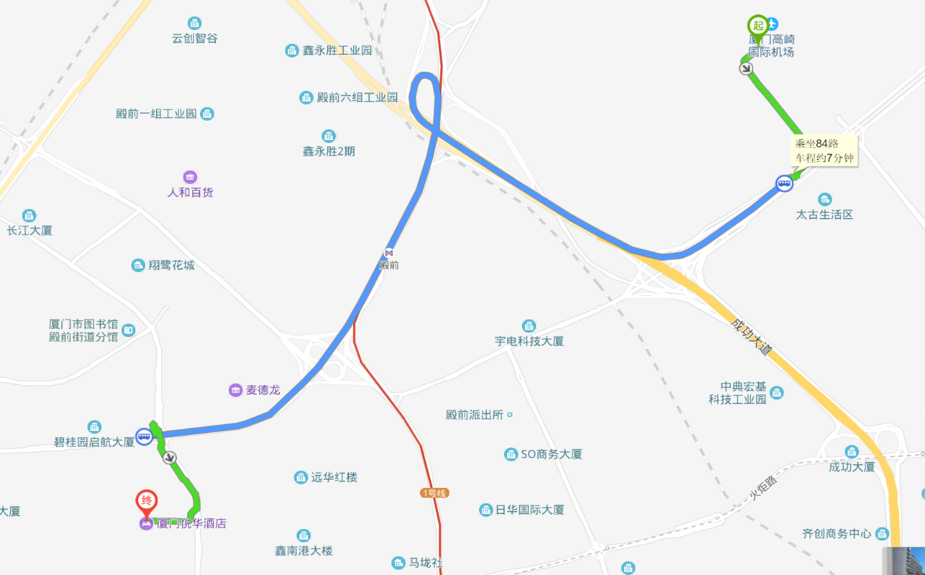

Xiamen Gaoqi Airport

Get on No.84 bus station ‘Tai Gu Su She’ (太古宿舍站)

‘Chang Hao Lu Kou’ (长浩路口站)

Xiamen C&D Hotel

**Note:** If you take a taxi, for convenience, please show the following information in Chinese to the driver:

**To Xiamen C&D Hotel:**

**我要去：厦门悦华酒店**

To Xianglu grand Hotel：

我要去：厦门翔鹭酒店

To Le Meridien Xiamen：

我要去：厦门艾美酒店

**MAP**

Location of the meeting venue, recommended hotels and restaurants.

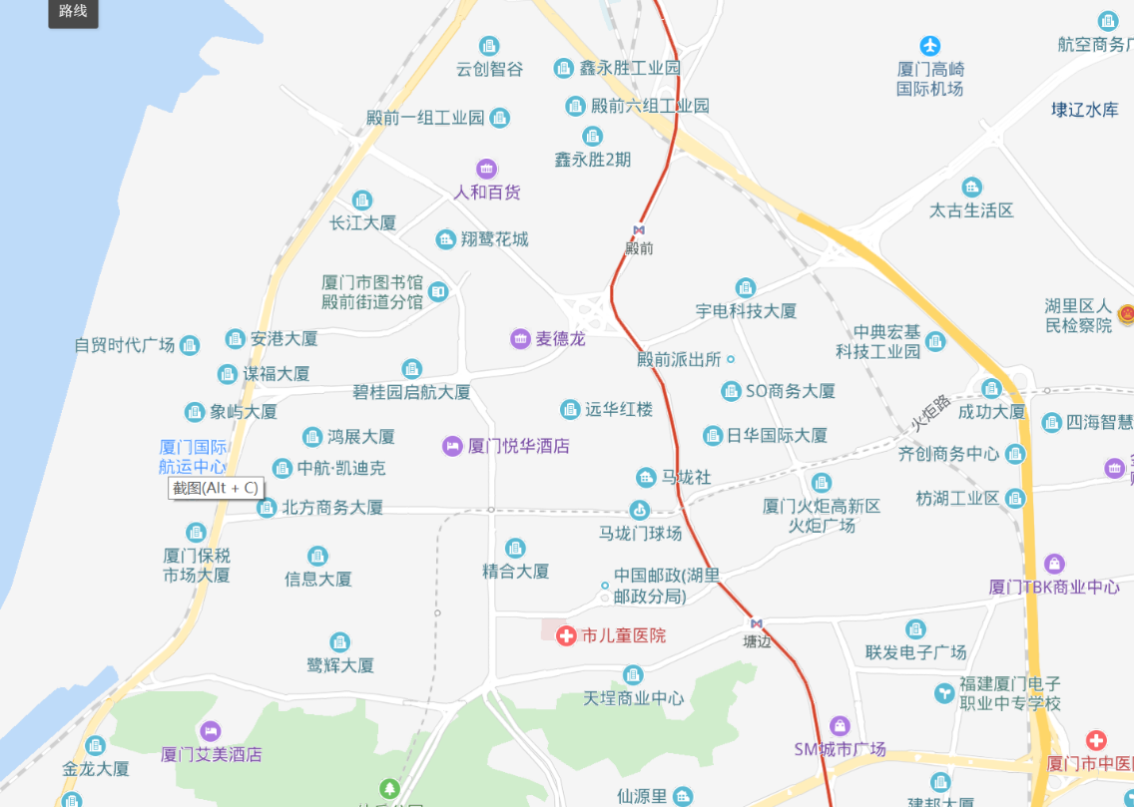

Xianglu grand Hotel

Xiamen C&D Hotel

Le Méridien Xiamen

Xiamen Gaoqi Airport

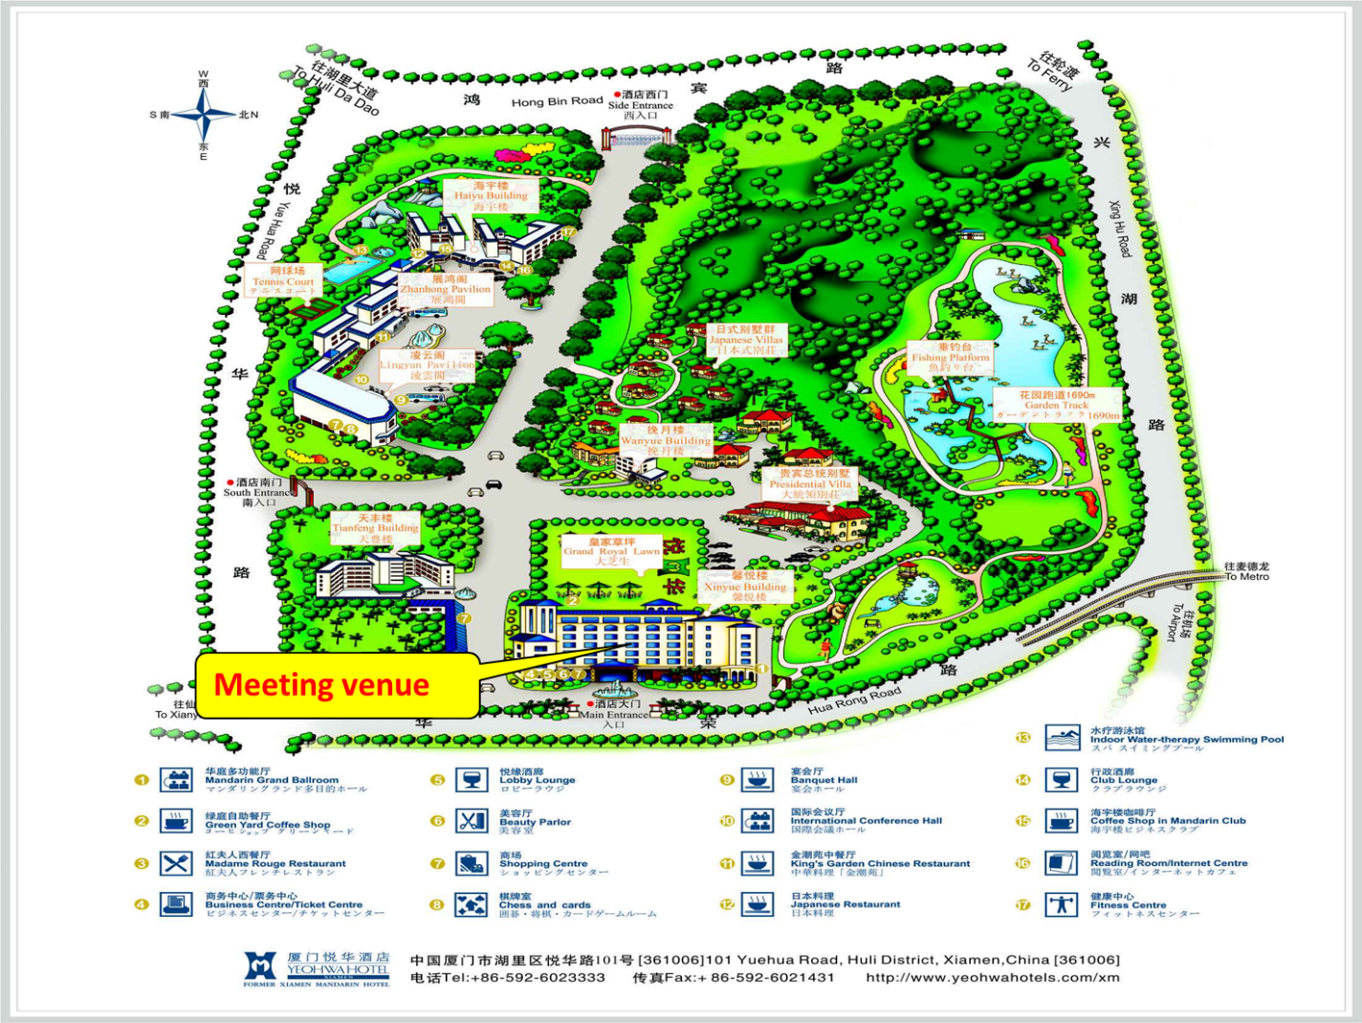

**MEETING REGISTRATION**

Participants will be able to register and pick up their information package from 8:30 to 9:00 on the first day of each meeting. If this registration time is not convenient for you, please ask the Secretariat staff in the meeting room for your registration.

**SOCIAL EVENTS**

*There will be two receptions organized by the host Member and the Commission:*

*7 November, 6:30-8:00pm – ZhanHong Room in Xiamen C&D Hotel*

*12 November, 6:30-9:00pm – LuTing cafeteria in Xiamen C&D Hotel*

***All meeting participants are welcome!***

**OTHER INFORMATION**

WIFI-1(Recommended) SSID: @cndhotel Password: login via webpage

WIFI-2 SSID: NPFC2018 Password: npfcxiamen

WIFI-3 SSID: NPFC2018_Backup Password: npfcxiamen

**Electricity**

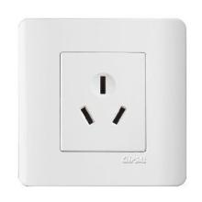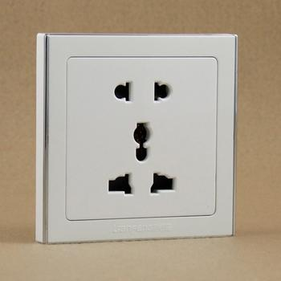The voltage in China is 220 Volt (50HZ). Most devices with their own transformers such as laptops, camera and smartphone chargers can be directly used, but a portable plug adaptor may be necessary to use your electronic devices.

**EMERGENCY INFORMATION**

*Police* Emergency call – 110

*Fire or Emergency Rescue* Emergency call – 119

*Ambulance* Emergency call – 112

******************************************************************************

If you have any questions regarding visas, please do not hesitate to contact:

Mr. Chuanxiang Hua

E-mail: cxhua@shou.edu.cn

Tel: +86-15692166362

If you have any questions regarding meeting preparations, please do not hesitate to contact:

Dr. Aleksandr Zavolokin

E-mail: [azavolokin@npfc.int](mailto:azavolokin@npfc.int)

Tel: +81-3-5479-8717

**Attachment 1**

The Shanghai Ocean University is willing to prepare an Invitation Letter for your visa application to attend the NPFC Meetings in Xiamen, CHINA. Please provide a list which includes the following information to Mr. Chuanxiang Hua ([cxhua@shou.edu.cn](mailto:cxhua@shou.edu.cn)) by **25 September 2018**.

*If you need the invitation letter from* ***the government of China****. Please provide a list which includes the following information to Mr. Lianyong Fang (*[*admin1@tuna.org.cn*](mailto:admin1@tuna.org.cn)*) and Mr. Chuanxiang Hua (*[*cxhua@shou.edu.cn*](mailto:cxhua@shou.edu.cn) *) by 25 September 2018*

EXAMPLE

First Name: Chuanxiang

Last Name: HUA

Gender(F/M): M

Passport Number: PEXXXXX

Date of Birth: March 12, 1982

Job Title: Assistant Director

Agency/Organization: Shanghai Ocean University

Period of Stay in CHINA：April 16-Aril 28, 2017

Full Contact Address: 999 Huchenghuan Road, Shanghai, 201306 China

Email Address: cxhua@shou.edu.cn

Telephone: +86-21-61900304

Fax: +86-21-61900304

First Name:

Last Name:

Gender(F/M):

Passport Number:

Date of Birth:

Job Title:

Agency/Organization:

Period of Stay in CHINA：

Full Contact Address:

Email Address:

Telephone:

Fax:

**Attachment 2**

**Room reservation of C&D hotel**

**2018 NPFC Meeting, XIAMEN, China**

|  |  |  |  |  |
| --- | --- | --- | --- | --- |
| **Name of Guest** |  | **Telephone Number** |  | |
| **Arrival Date** |  | **Arrival Time** |  | |
| **Departure Date** |  | **Departure Time** | 12:00 | |
| **Type of Room** | **Daily Rate Per Room &Breakfast** | | **No. of Rooms** | **Select by ‘✓’** |
| **Tianfeng Superior Room （king bed）** | 500 CNY  (Inclusive of 1-2 daily buffet breakfast and 15% service charge) | | 1 |  |
| **Tianfeng Superior Room （twin beds）** | 500 CNY (Inclusive of 1-2 daily buffet breakfast and 15% service charge) | | 1 |  |
| **Xinyue Deluxe Garden View room （Kind bed）** | 600 CNY (Inclusive of 1-2 daily buffet breakfast and 15% service charge) | | 1 |  |
| **Xinyue Deluxe Garden View room （twin beds）** | 600 CNY (Inclusive of 1-2 daily buffet breakfast and 15% service charge) | | 1 |  |
| **Payment Method** | All room and incidental charges will be settled by the guest upon check out. | | | |
| **Warm Prompt** | 1. Check-in time is 14:00. The earlier check-in is subject to room availability. Check-out time is 12:00. Half daily room rental is charged for late check out till 18:00, and one full daily room rental is charged for check out after 18:00. Reservation will be held till 18:00 unless guaranteed by advance deposit or advised of the late flight details. | | | |
| 1. according to the regulations of XIAMEN city public security organs, the adult and juvenile passengers shall hold ID Card or other valid certificates check-in, from minor passengers not to handle ID Card, should hold the "residence booklet" check-in, not dependency underage passengers should with valid documents to police station of the temporary residence certificate. Baby less than one year old and yet been settled in their guardians of minors under the need to show your "birth certificate". Thank you for your understanding and support! | | | |
| 1. **E-mail Address of C&D Hotel Reservation Department:** [**rsvnxm@cndhotels.com**](mailto:rsvnxm@cndhotels.com) | | | |